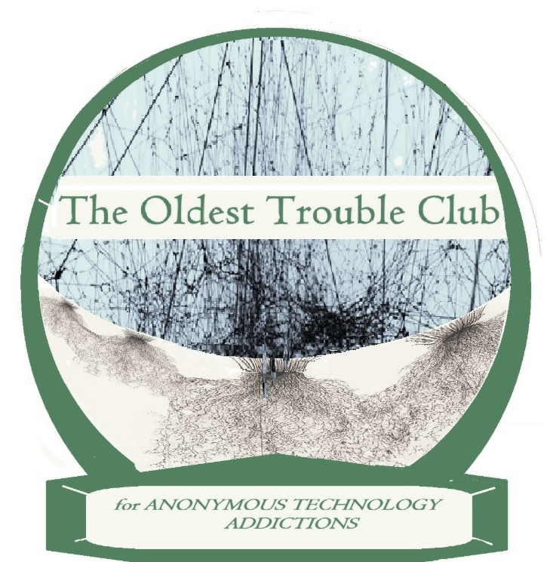

Meeting Guide
‘The Little Big Book’

The Oldest Trouble Club (OTC) has been founded during an era of uncertainty, when human tools have become the keystone of civilization, yet the very competence to sustain ourselves and our earth is in question. We believe that our best hope is in coming to understand and respect our emotions. These represent our roots, our dignity as well as our oldest trouble.

A TYPICAL MEETING FORMAT

Welcome to the _______(name/day) Oldest Trouble Club meeting. At this meeting anyone is welcome, especially if you feel powerless over the world or your work, your school, your family, or anything.

We will open with 60 seconds of silence, followed by the Serenity Prayer
[silence]
(everyone) “Grant me the serenity to accept the things I cannot change, courage to change the things I can, and the wisdom to know the difference.”
Let’s introduce ourselves. We can say our whole name and what we do, or how we keep busy. Feel free to pass out cards at the end of the meeting Let’s go around the room to my right, “I’m _________.”

Would someone like to read the OTC Purpose?
Would someone like to read the Problem? The Solution?
Would someone like to read What is a Share?

I’ve chosen ______________ for our kick-off reading. Would someone like to begin?
[after the reading]
There are { } people here, so shares should be limited to ( N )-minutes. At (N+1) minutes our timekeeper will give you a sign to wrap up in ONE.

If there are no more shares, does someone have a suggestion for another reading?

Before closing with the “We” version of the Serenity Prayer, could I have a volunteer to chair the next meeting?”

(everyone) “Grant us the serenity to accept the things we cannot change, courage to change the things we can, and the wisdom to know the difference.”

The OTC Purpose
An individual OTC club’s primary purpose is to provide a secure place where people of all ages can ‘check-in’ on their technology uses and abuses - touching the same ground with others through their emotional roots, and sharing whatever those feelings might be.
Each club reaches out to new generations of technology users as well as its future inventors and engineers to cultivate a mindfulness of the modern state of civilization respecting psychological life.
Emotional life, with or without our modern technological assets, can be both curious, confusing, and often dysfunctional. This shifting panorama of experience is what we wish to uncover and share, with whatever honesty we can muster.

If you are here, and feel even somewhat powerless over your world, join the club! Those are emotions, and you can be sure there are others just like you.
.
The PROBLEM
Many years ago, Marshall McLuhan noted that all our technologies are extensions of ourselves. In “Understanding Media” he prophesied a time around the corner when they would become continuous with our cognitive senses and our minds. The computer science of steering systems had just been introduced. Norbert Wiener fearfully changed the title of his book “Cybernetics” to “The Human Use of Human Beings,” warning how Information Science would become perverted. The fictional “Brave New World” is here; Aldous Huxley’s dystopia has come true.
Our lives are based around a sense of self, and our sense of self is grounded in our emotions—yet the ‘ground’ is not on the ground --it depends on an outside connection. We must be plugged-in to work, to get anything done, or to feel good. We are powerless without our ‘fix.’ It is like an emotional charge that allows current to flow. We are fixed by someone in another space and time; fixers we have faith in, even though we know they cannot be trusted.
This shall remain the emotional quandary of our century. If we cannot face up to it, our extensions shall be our emotional life. Others shall own us, trade us, and direct us.

The SOLUTION
Given the all-pervasiveness of technology, the solution is subtle. It is an artform of “sharing” discovered in the rooms of addiction recovery. It is based on the nature of what is called ‘social cognition,’ allowing us to untangle the roots of self in the true ground of emotional experience. We can develop a mindfulness in a personal space and time, face to face with others acknowledging the same problem, just like us. We call this grounded social cognition ‘meta-mindfulness.’
When we are present in a meeting we have a single focus, to share our feelings of powerlessness. By doing this we charge each other’s batteries in person, detaching our emotions from their technological currents. This is how we discover and re-invent our freedom, power, and balance to take on the world at large, without a hit, without our social, worldly ‘fix.” The gold-standard of meta-mindfulness is face-to-face; there is no interest in cyber-currency.

What is a SHARE?
When something we read reminds us of our experience, we share it. It isn’t a ‘preach’ or a chance to show off knowledge. We use the share to open up and discover what the experience means to us at that precise moment of the day. We seek to bring our insides out, leading with what we’re unsure of. Searching out our feelings, the share acts as the prism, the group is our mirror. When others share, we listen. We don’t break in or comment, for mirrors don’t talk back.
With sufficient courage, the share works like a prism of the soul that lets the light of the spirit shine through. “Sharing” is a means of sorting things out in front of a ‘mirror’ of other people who are, in many ways, just like us. A good share will separate out the colors —the source of our emotions. And we find them through others. It is the secret of why 12-step programs like AA, DA, GA, NA, OA, SA and the rest of them work. Because a mirror is anonymous and keeps the secret of what you look like at that moment. We see ourselves through the eyes of others, yet always remember to respect the next person’s courage. “What you hear here, let it stay here.“

How Sharing Works
A share is a special form of talk - a kind of solitaire of words with others present to make sure you stick to the rules. To listen to another person’s share is to hear someone carefully thinking out loud, and often enough quite by accident we recognize ourselves in the words of someone we thought was not at all like us. When that happens our world changes just a bit, and the reason is probably this:
It is said that a person’s sense of self has developed from infancy onward, around the representations of, and the relationships with, other people. So when our sense of self is confronted with a confirmation through someone else in an accidental way, it is similar to how we picked things up in childhood, through a sense of play. And this can be fun. This, at least, is our conjecture. It is why sharing works, and why it sometimes works wonders.

What is “Emotional Sobriety”?
Emotional sobriety is the terminology borrowed from AA for emotional well-being, cognitive balance and mental health. It refers, of course, to alcohol, and being ‘sober’ rather than tipsy or drunk. We all know people who get ‘drunk’ on their emotions - displaying to all whatever mood catches them at a given moment, then riding it like a surfer on a wave. Most of us, however, rarely get so drunk on our emotions that we are out of control. Often, we enjoy the feeling of being in touch with some deeper roots in the ground of our lives, a hint of power...of a fertile strength. But as we all eventually come to realize, these feelings of well-being are not just up to us, and they are indescribable in a few simple words. Different attempts to describe these positive feelings can be found in the last section of this book, where we have provided the PROMISES of many different 12-step recovery programs. This is about as close to “emotional sobriety” as one can get.
What ARE the Emotions?
You may as well ask ‘why do all the eels in the world return to the Sargasso Sea to spawn? Our emotions are as deep as the permutations of amino acids in our DNA. If you were to capture the code, you may well have discovered the “spell” of life, a “spell” that can only be momentary. Life stands in a river of time that is never the same. The banks of our river change, as mud and pebbles are swept downstream.
There are as many colors of emotion as the shapes of chaos— and just as many ways to bring our emotions into harmony. That is the nature of your Higher Power. You will be either convinced of chaos or brought to your Higher Power by the nature of the stream and your experience of life. These are the emotions, and your story is the stream. Our bodies and minds are a two-way partnership that must flow with the world-flow. We are an ‘event,” a body like a river. The Oldest Trouble Club can help us learn to stand in that river.

Strategies of Discovery and Optional Paths to Action
Your river might still be short or very long, but within it there are twists and currents, rapids and whirlpools, stagnant pools and swamps, even waterfalls. These are the stories in our narratives that we wish to discover with our fellow club-members. We search out these stories, and clear out the flows where they are muddy or turbulent. This is the meta-mindful process. And the job may be bigger than we thought; moving rocks and clearing the swamp might take an engineering crew with experience. The 12-step programs of action are those crews. You might want to join one or more of them for a time to straighten out those kinks in your river, recovering the flow. It’s said a tractor mired in mud only digs itself in deeper by spinning its wheels; it needs to hook up to other tractors to pull itself out.

The chart below shows the O.T.C. 4-step ‘strategy’, which may be all we need. These correspond, however, to a plan of action, which is expressed as the familiar 12-steps introduced by AA. These correspond with twelve life steps that are the promises of emotional balance and ‘sobriety.’
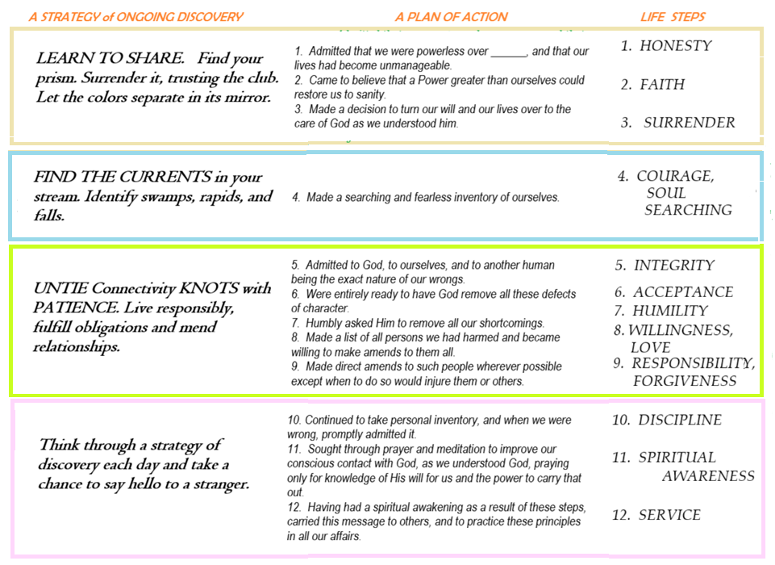

How Meetings Work
At each meeting, the person chairing for that week will choose six or seven paragraphs about emotions or our technological ‘fix’ that can be read consecutively by group members to “prime the pump” for sharing.
The “pump primer”(PP) can be a page or two from a book, a novel, poem or song lyric. When there are no more shares on the reading, the chair will ask for suggestions from the club’s literature or a reading one from the ‘Promises’ or ‘Pump Primers’ at the end of this book.
At the end of each meeting someone volunteers to chair the next meeting and pick out the opening reading.

The Club Library
Any suitable books might be chosen by a club for their ‘library.’ The first club had the following books in a milk-crate that were brought to each meeting: As Bill Sees It (AA - 6 copies); Emotions Anonymous Big Book (5 copies); The Little Red Book (AA, 5 copies); Coming to your Senses (Kabat-Zinn, 5 copies); How to Turn Anger into Love (Siddique & Siddique, 3 copies); Emotional Intelligence (Goleman, 3 copies); The Road Less Travelled and Beyond (Peck, 3 copies)

The Traditions
The “Traditions” are the organizational guidelines for individual clubs to follow. They are provided so that this guidebook has everything needed to get started. As a child of the 12-Step tradition, the OTC recognizes that each individual fellowship is their own organization, which can decide what and how it wants to hold meetings, or become something more. Because we have no reasons to maintain anonymity, that “something more” could be much like a service club (think of Kiwanis, or Rotary), which becomes involved in its community in a wider sense. For this reason, the Traditions must differ somewhat from those 12-Step recovery members are familiar with:

TRADITIONS
1. Our common welfare should come first; our recovery from powerlessness depends on OTC unity.
2. For the group purpose there is but one ultimate authority – a Higher Power that may express itself in our group conscience. Our leaders are but trusted servants; they do not govern.
3. The only requirement for OTC membership is to share and a desire to learn how.
4. Each group should be autonomous except in matters affecting other groups or OTC as a whole.
5. Each group has but one primary purpose – to carry its message of an emotional fellowship to others.
6. An OTC group is autonomous and stands for itself; it can only endorse, finance, or create obligations through its own unique OTC name.
7. Every OTC group ought to be fully self-supporting; however, may create a charter and bylaws to become a non-profit service organization or B-corporation. Any “children” of such organizations, by Tradition 2, must be independent and self-supporting.
8. The Oldest Trouble Club as a fellowship should remain forever non-professional, but our service centers may employ special workers.
9. OTC, as such, ought never be organized; but we may create service boards or committees directly responsible to those they serve.
10. The Oldest Trouble Club has no opinion on outside issues; hence the O.T.C. name ought never be drawn into public controversy.
11. Our public relations policy is based on attraction through a wide variety of social media which invite open participation. Those identifying themselves with OTC membership should treat all communications as a form of sharing, maintaining Tradition 10 as ‘sacred.’
12. Emotional balance is the spiritual foundation of all our traditions, ever reminding us to place principles before personalities.

Starting a New Club
It only takes two people to have a meeting and start a club (or visa versa). If and when you find a regular meeting place, simply apply to be a member of the Facebook Group page (see Social Media, below). You will be asked for meeting and contact information and we will send you a printable version of the “Littlest Bigbook.”

THE BACKSTORY (how O.T.C. started

The Oldest Trouble Club was created by a non-profit bookstore called 12 Steps & More Books, which was begun in the vestibule of the oldest Episcopal church in Trenton, NJ. The bookstore had been created through a grant from the church diocese as a brick & mortar location where 12-Step materials could be bought for all the various 12-step groups, advertising this method of mental/spiritual health in all sorts of addictions. This was, however, a subversive way to let a broader public know about internet-related addictions, particularly those which one cannot openly speak of or seek help for (as opposed to substance abuse, or eating addictions, gambling or credit-card spending). For our society is overly-addicted to subtle and unsubtle forms of emotional stimulation, and our young are not finding any real guidance in the matter.
So the idea of new clubs was brought up, especially those that might be founded by and attended by youth without mentioning any taboo subjects. It was originally to be called “Steps & Promises clubs,” but was dropped for a more catchy name that made you think of some taboo. And so, following on the mission statement of the 501c3 non-profit 12 Steps & More Books, the idea of The Oldest Trouble Club was hatched, and we are hoping you will be successful in starting your own club with this littlest Big Book as a guide.

PROMISES
This section of the book provides definitions for emotional sobriety that were worked out by different 12-step fellowships. These might be taken as guideposts for what we are after in our path through life.
Alcoholics Anonymous Promises
The AA Promises are shared by many other fellowships such as Overeaters Anonymous (OA) and Sexaholics Anonymous (SA).
- If we are painstaking about this phase of our development we will be amazed before we are half-way through.
- We are going to know a new freedom and a new happiness.
- We will not regret the past nor wish to shut the door on it.
- We will comprehend the word serenity and we will know peace.
- No matter how far down the scale we have gone, we will see how our experience can benefit others.
- That feeling of uselessness and self-pity will disappear.
- We will lose interest in selfish things and gain interest in our fellows.
- Self-seeking will slip away.
- Our whole attitude and outlook on life will change.
- Fear of people and economic insecurity will leave us.
- We will intuitively know how to handle situations which used to baffle us.
- We will suddenly realize that God is doing for us what we could not do for ourselves.
Are these extravagant promises? We think not. They are being fulfilled among us - sometimes quickly, sometimes slowly. They will always materialize if we work for them.

AL-ANON Promises (officially, AL-Anon does not make promises. The following have been adopted by some AL-Anon groups)
- If we willingly surrender ourselves to the spiritual discipline of the Twelve Steps, our lives will be transformed. We will become mature, responsible individuals with a great capacity for joy, fulfillment, and wonder.
- Though we may never be perfect, continued spiritual progress will reveal to us our enormous potential. We will discover that we are worthy of love and loving.
- We will love others without losing ourselves, and will learn to accept love in return.
- Our sight, once clouded and confused, will clear and we will be able to perceive reality and recognize truth.
- Courage and fellowship will replace fear.
- We will be able to risk failure to develop new, hidden talents.
- Our lives, no matter how battered and degraded, will yield hope to share with others.
- We will begin to feel and will come to know the vastness of our emotions, but we will not be slaves to them.
- Our secrets will no longer bind us in shame.
- As we gain the ability to forgive ourselves, our families, and the world, our choices will expand.
- With dignity we will stand for ourselves, but not against our fellows.
- Serenity and peace will have meaning for us as we allow our lives and the lives of those we love to flow day by day with God’s ease, balance, and grace.
- No longer terrified, we will discover we are free to delight in life’s paradox, mystery, and awe.
- We will laugh more.
- Fear will be replaced by faith, and gratitude will come naturally as we realize that our Higher Power is doing for us what we cannot do for ourselves.

Narcotics Anonymous Promises
A whole new life opens up. We do recovery. Slowly our life changes and if we learn rigorous honest these promises come true.
1. We begin to feel worthwhile.
2. We develop self-esteem.
3. We get a better perspective on life.
4. We will be unafraid.
5. We come to know ourselves.
6. We experience new sensations.
7. We do things we never thought we could do and enjoy.
8. We make mistakes and accept and learn from them.
9. We experience failure and learn how to succeed.
10. We become more loving.
11. We become more clear in our thinking.
12. The obsession of self is removed.
13. We become a productive and responsible memb er of society.
14. The future becomes an exciting journey.
15. We become increasingly open-minded.
16. We find a God who cares for us and will do for us what we cannot do for ourselves.
Adult Children of Alcoholics (ACOA) Promises

1. We will discover our real identities by loving and accepting ourselves.
2. Our self-esteem will increase as we give ourselves approval on a daily basis.
3. Fear of authority figures and the need to “people-please” will leave us.
4. Our ability to share intimacy will grow inside us.
5. As we face our abandonment issues, we will be attracted by strengths and become more tolerant of weaknesses.
6. We will enjoy feeling stable, peaceful, and financially secure.
7. We will learn how to play and have fun in our lives.
8. We will choose to love people who can love and be responsible for themselves.
9. Healthy boundaries and limits will become easier for us to set.
10. Fears of failure and success will leave us, as we intuitively make healthier choices.
11. With help from our ACA support group, we will slowly release our dysfunctional behaviors.
12. Gradually, with our Higher Power’s help, we will learn to expect the best and get it.

Workaholics Anonymous Promises
If we are completely honest about ourselves, and together we apply the Steps, Traditions, Tools, and Principles in our lives, we will soon begin to receive these gifts of sanity and balance:
- We are not obsessed by work or plagued by work aversion.
- Adrenaline seeking loses its hold on us. Excessive worry and anxiety become a thing of the past.
- We have a daily action plan that faces the reality of time as well as priorities such as recovery, recreation, and relationships.
- Fears that there will not be enough time, money, or love leave us.
- We learn to play and have fun together.
- We repair broken relationships and build new ones.
- Health and self-nurturance return.
- Self-seeking and ego inflation do not drive our decisions.
- We lose interest in selfish things. We gain interest in—and compassion for—our partners, families, friends, and coworkers.
- We experience how well the program helps us to handle problems that used to confuse and defeat us.
- We ask for help and reach out to help others.
- We find that a Higher Power helps us in a way that self-reliance never could.

Sex and Love Addicts Anonymous Promises

1. We will regain control of our lives.
2. We will begin to feel dignity and respect for ourselves.
3. The Loneliness will subside and we will begin to enjoy being alone.
4. We will no longer be plagued by an unceasing sense of longing.
5. In the company of family and friends, we will be with them in body and mind.
6. We will pursue interests and activities that we desire for ourselves.
7. Love will be a committed, thoughtful decision rather than a feeling by which we are overwhelmed.
8. We will Love and Accept ourselves.
9. We will relate to others from a state of wholeness.
10. We will extend ourselves to nurture our own spiritual growth and that of others.
11. We will make peace with our past and make amends to those we have harmed.
12. We will be thankful for what has been given us, what has been taken away and what has been left behind.

Debtors Anonymous Promises

- Where once we felt despair, we will experience a newfound hope.
- Clarity will replace vagueness. Confidence and intuition will replace confusion and chaos. We will live engaged lives, make decisions that best meet our needs, and become the people we were meant to be.
- We will live within our means, yet our means will not define us.
- We will begin to live a prosperous life, unencumbered by fear, worry, resentment or debt.
- We will realize that we are enough; we will value ourselves and our contributions.
- Isolation will give way to fellowship; faith will replace fear.
- We will recognize that there is enough; our resources will be generous and we will share them with others and with D.A..
- We will cease to compare ourselves to others; jealousy and envy will fade.
- Acceptance and Gratitude will replace regret, self pity and longing.
- We will no longer fear the truth; we will move from hiding in denial to living in reality.
- Honesty will guide our actions towards a rich life filled with meaning and purpose.
- We will recognize a Power greater than ourselves as the source of our abundance. We will ask for help and guidance and have faith that they will come.
All this and more is possible. When we work this program with integrity and to the best of our ability, one day at a time, a life of prosperity and serenity will be ours.

Co-Dependents Anonymous Promises

1. I know a new sense of belonging. The feeling of emptiness and loneliness will disappear.
2. I am no longer controlled by my fears. I overcome my fears and act with courage, integrity and dignity.
3. I know a new freedom.
4. I release myself from worry, guilt, and regret about my past and present. I am aware enough not to repeat it.
5. I know a new love and acceptance of myself and others. I feel genuinely lovable, loving and loved.
6. I learn to see myself as equal to others. My new and renewed relationships are all with equal partners.
7. I am capable of developing and maintaining healthy and loving relationships. The need to control and manipulate others will disappear as I learn to trust those who are trustworthy.
8. I learn that it is possible to mend – to become more loving, intimate and supportive. I have the choice of communicating with my family in a way which is safe for me and respectful of them.
9. I acknowledge that I am a unique and precious creation.
10. I no longer need to rely solely on others to provide my sense of worth.
11. I trust the guidance I receive from my Higher Power and come to believe in my own capabilities.
12. I gradually experience serenity, strength, and spiritual growth in my daily life.
Gamblers Anonymous Promises

As the door to the past life closes, the door to a new life opens.
There was no faith or hope and now there is.
Money falls into its proper place.
No longer are material objects the only aim and ambition.
A Higher Power and you walking side by side can work together each day so that you can become better than you have ever been.
No longer will you be lonely.
No longer do you make the decisions.
Life has a balance which it has lacked.
In a crowd or by yourself, you are no longer alone.
You will see yourself more clearly.
This insight will remain.
Self-knowledge has no bounds.
Your newfound serenity will enable you to calmly listen and learn.
Your awareness will really accelerate.
What the program teaches comes true.
You continue to let go of the old ways and allow your Higher Power to guide you towards peace and serenity.
All fear will dissipate.
You will be free to talk and move about as a normal person.
You will be able to resume a beneficial role in society.
Self-respect, so long absent, starts to return.
The ability to cope is perhaps the most valuable reward which you will receive.
One no longer has to avoid a problem by ignoring or side-stepping the issue.
One day at a time becomes a lifetime.

Food Addicts Anonymous Promises

- We will know freedom and the promises of a happy and healthy life.
- Our creativity will flow with the self-discipline we need to put it into action.
- The chaos inside us will be gone, so the chaos around us will diminish.
- Our thinking will become clear.
- We will be able to learn new information and knowledge and retain what we have learned.
- We will accomplish complicated tasks with less confusion than before we were abstinent.
- We will be consistent and dependable.
- We will no longer fear trying something new and different.
- If an endeavor is unsuccessful, we will be able to regroup and try it a new way.
- We will be able to listen to others’ ideas and suggestions without becoming defensive or argumentative.
- We will become present and alert around our friends, family, and significant others.
- We won’t have to shut down, dissociate, or avoid listening any more.
- We can be ourselves because we won’t allow abuse of any kind to be done to us by ourselves or others.
- We will no longer attempt to fill our emotional and spiritual needs through our mouths. Instead, we will use our mouths along with our hearts to ask for what we need and deserve as children of God.
- We will be able to listen with empathy to others’ suffering.
- We will not need to be controlling or insistent that “our way is best.”
- We will no longer be judgmental about everyone we meet.
- The urge to see all the ways we were less sick than others will leave us.
- Our self-esteem will no longer be tangled up in our perceptions about our bodies.
- If on any given day we think we look fat, ugly or old, we can choose not to lash out in anger or frustration at the people around us.
- We will be able to hear and feel our Higher Power in our hearts and be still.
- We will no longer experience the panic, fear, and anxiety of our yesterdays.
- When presented with multiple choices, we will be able to reach clear decisions and understand what is appropriate for us.
- We will know freedom from the fear of change in our relationships with the community, our families, and our friends.
- We will begin to trust our intuition.
- We will cherish our abstinence as critical to our physical, emotional, and spiritual survival, and we will stay abstinent!

EMOTIONS ANONYMOUS Promises

- We realize a new freedom and happiness.
- We do not regret the past or wish to shut the door on it.
- We comprehend the word serenity, and we know peace of mind.
- No matter how far down the scale we have gone, we see how our experience can benefit others.
- The feelings of uselessness and self-pity lessen.
- We have less concern about self and gain interest in others.
- Self-seeking slips away.
- Our whole attitude and outlook upon life changes.
- Our relationships with other people improve.
- We intuitively know how to handle situations which used to baffle us.
- We acquire a feeling of security within ourselves.
- We realize that God is doing for us what we could not do ourselves.
These may seem like extravagant promises, but they are not. They are being fulfilled among us, sometimes quickly, sometimes slowly.

A Potpourri of Pump Primers

A Partial List of Feelings & Emotions

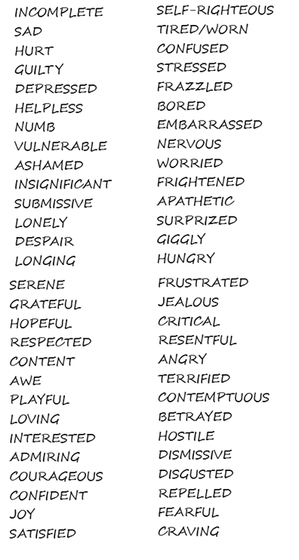

Another view of the “Oldest Trouble”

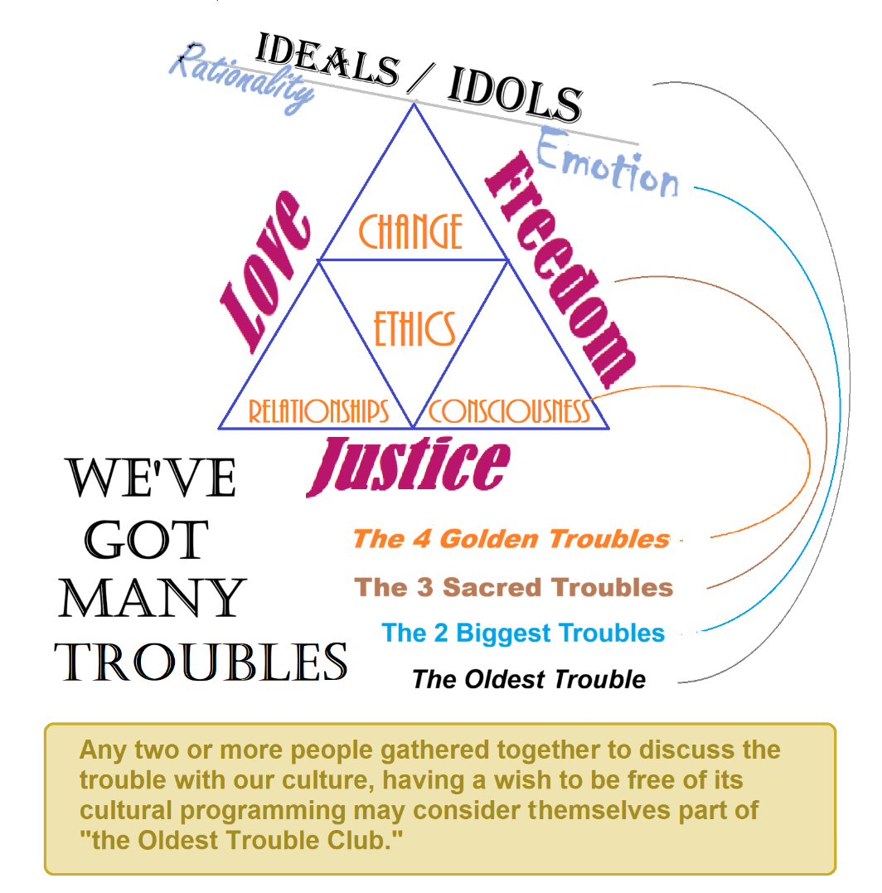

Social Media:
Substack: theoldesttrouble.substack.com --OTC primary documents & club readings
- Rhizomaticajournal.substack.com —a journal on emotional well-being…etc.
Facebook Group: https://www.facebook.com/groups/theoldesttroubleclub--Sign ups & post OTC news

Contacts: 12stepsandmore@gmail.com
Information on all of the 12-step recovery groups can be found on the 12steppers.org website

DISCLAIMER: The Oldest Trouble Club is NOT the already well-established London-based TROUBLE CLUB which is a wonderful organization for women and communities. We do not wish to “bite-off” from this club’s reputation, but believe that emotional well-being is, in fact, “the oldest trouble” for women AND men AND children who are unsure of anything or sure of everything.
The meeting format is typical of a 12-step meeting, where the opening ‘prayer’ and readings serve to set the tone.

